**10 SCIENCE BIOLOGY INVESTIGATION: DNA EXTRACTION 2015**

[](http://www.google.com.au/imgres?imgurl=http://www.recruiter.com/i/wp-content/uploads/2013/08/CURIOUS-INTERESTED-CAT-DOCTOR.jpg&imgrefurl=http://www.recruiter.com/i/we%E2%80%99re-interested-really-means-what%E2%80%949-kinds-of-interest-you-need-to-distinguish/&h=900&w=900&tbnid=1db40oenmDYzlM:&zoom=1&q=cat%20doctor&docid=HXVVIXheb0NeSM&ei=ZsvRU8CcLdKJuAT_-YHQCg&tbm=isch&ved=0CF0QMyg3MDc&iact=rc&uact=3&dur=118&page=2&start=47&ndsp=45)

Name:_________________________ Teacher: Miss Cerny

Form:_________________________ Due date:___________

Living things are made up of cells which contain the genetic code which distinguishes them from other living thing. This code is found in the chemical inside the nucleus of cells, DNA.

Your task is to extract (take out) the DNA from a piece of kiwi fruit.

**Plagiarism**

You must write in your own words not copy sentences word for word from another student or another source.

Plagiarising = instant zero on assignment and you will have to re-do it.

**Assessment policy**

Have sick note/legitimate reason from parent = new negotiated due date.

Assignment not submitted on due date and no sick note from parents = -20% mark

Assignment not submitted on new negotiated due date = -40% mark

+ Letter home to parents.

+ Must attend academic completion to complete assignment.

**OR**

Submit assignment to student services before academic completion date and academic completion not necessary.

Academic completion not attended = zero on assignment + Saturday detention.

**If you know that you cannot submit your assignment on the due date, let your teacher know BEFORE the due date (email them if you are not in school) or just email them your assignment the night before.**

**Title** (write a title for the investigation, needs to be detailed. (1 mark)

_________________________________________________________________________________________________

_________________________________________________________________________________________________

**Aim** (what do you want to discover by doing this experiment?) (2 marks)

_________________________________________________________________________________________________

_________________________________________________________________________________________________

_________________________________________________________________________________________________

_________________________________________________________________________________________________

**Materials** (list all materials used, be specific with number of items used and amounts or sizes). (2 marks)

_________________________________________ ______________________________________________

_________________________________________ ______________________________________________

_________________________________________ ______________________________________________

_________________________________________ ______________________________________________

_________________________________________ ______________________________________________

_________________________________________ ______________________________________________

**Method:**

1. Blend the piece of kiwi fruit using the blender.

3. Place pulp in a large test tube. Set aside.

4. Add 25ml of hot tap water to a beaker and add 1 teaspoon of salt. Mix with stirring rod.

5. Add enough salty water to **just** cover the kiwi pulp in the large test tube.

6. Carefully using a stopper in the end of the test tube; shake for 20 seconds.

7. Set up the filter paper in the filter funnel and sit in the filter funnel holder over the test tube using the retort stand.

8. Filter the shaken solution into another large test tube. This will take time.

DO NOT POKE A HOLE INTO THE FILTER PAPER WITH THE STIRRING ROD.

9. ***Slowly*** add 20 ml of methylated spirits down the side of the test tube making sure that the two solutions do not mix.

**Draw a labeled scientific diagram of your experiment set up filtering the solution.**  (3 marks)

Use a lead pencil.

Use a ruler to draw lines to label each piece of equipment.

Use the guide below to show you how each piece of equipment should be drawn.

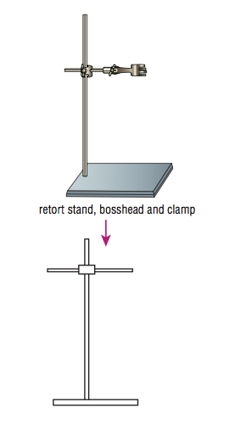

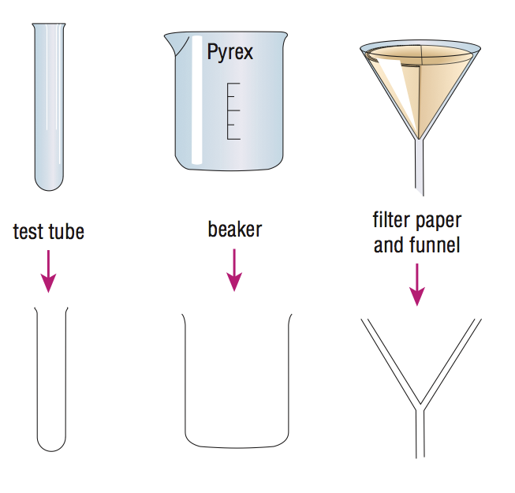

**Describe how to fold a filter paper to put into a filter funnel.**  (3 marks)

_________________________________________________________________________________________________

_________________________________________________________________________________________________

_________________________________________________________________________________________________

_________________________________________________________________________________________________

_________________________________________________________________________________________________

_________________________________________________________________________________________________

**Once you have the final test tube and you can see the DNA, draw a labeled scientific diagram of the test tube and label the substances in it (methylated spirits, DNA, kiwi fruit).**  (3 marks)

Use a lead pencil.

Use a ruler to draw lines to label the different substances.

**Discussion:** (6 marks)

Describe two mistakes/errors that occurred.

Explain how these mistakes/errors affected the results.

Explain how these mistakes/errors could be avoided.

_________________________________________________________________________________________________

_________________________________________________________________________________________________

_________________________________________________________________________________________________

_________________________________________________________________________________________________

_________________________________________________________________________________________________

_________________________________________________________________________________________________

_________________________________________________________________________________________________

_________________________________________________________________________________________________

_________________________________________________________________________________________________

_________________________________________________________________________________________________

_________________________________________________________________________________________________

_________________________________________________________________________________________________

_________________________________________________________________________________________________

_________________________________________________________________________________________________

_________________________________________________________________________________________________

_________________________________________________________________________________________________

_________________________________________________________________________________________________

_________________________________________________________________________________________________

_________________________________________________________________________________________________

_________________________________________________________________________________________________

_________________________________________________________________________________________________

_________________________________________________________________________________________________

_________________________________________________________________________________________________

_________________________________________________________________________________________________

_________________________________________________________________________________________________

_________________________________________________________________________________________________

Written neatly. (1 mark)

Correct grammar and spelling. (1 mark)

Total mark: /22

Percentage: %

Teacher’s comments:

__________________________________________________________________________________________________________

__________________________________________________________________________________________________________

__________________________________________________________________________________________________________

__________________________________________________________________________________________________________

__________________________________________________________________________________________________________

__________________________________________________________________________________________________________